Data Biography for Dataset Lorenzxyz

The dataset *Lorenzxyz*.*xls* comes from a Simulink model simulation of a model on the Matlab Community site. See nonlinear_model_plot.mdl Here is a picture of the model:

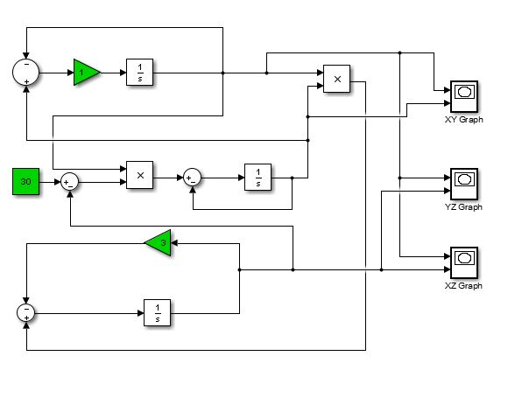

ZY

Y

X

It contains 3777 time sampled data rows of three variables (x y z) exhibiting chaotic behavior.

You can run the simulation with lower gains to stabilize and eliminate the chaos.

See Chapter 9 from *Nonlinear dynamics and Chaos* by Steven Strogatz for a description of the physical water wheel built at MIT that exhibits the behavior of the classic three Lorenz equations:

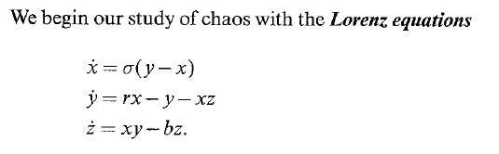

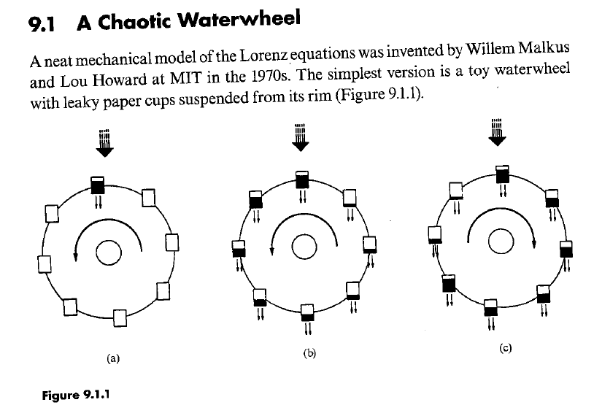

Don’t forget, Rajeev recommends transforming the spreadsheet so that several groupings of time samples appear as new columns